Context model

A context model is a type of a system context model that explicitly depits the boundary between the software system and its external environment.

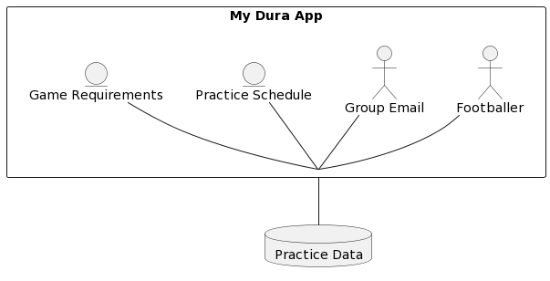

INTERACTIONAL MODEL

Interactional model provides the underlying structure for how a product or system behaves based on known user behaviours.

